Improving communications for Antimicrobial Resistance (AMR) in Africa. How should we move forward?

Antimicrobial agents, including antibiotics, have saved millions of lives, substantially reduced the burden of diseases in people and animals, improved quality of life, contributed to improved food production and safety, and helped increase life expectancy.

However, the emergence and spread of antimicrobial resistance (AMR) is complicating the management of many infectious diseases. AMR is a major threat to development and the fight against infectious diseases. It endangers animal health and welfare, as well as food production. AMR also adversely affects the functioning of human, animal and plant health systems and economies.

What is Antimicrobial Resistance (AMR)?
AMR happens when microorganisms such as bacteria, fungi, viruses, and parasites change and become resistant to antimicrobial drugs, including antibiotics, to which they were originally susceptible to. This can be due to different factors such as the misuse or overuse of antimicrobials and exposure to counterfeit drugs. Moreover, when antimicrobials are present in the environment at low concentrations, they can accumulate in human populations via long-term exposure to drinking water, food, or consumer goods with unknown health consequences.

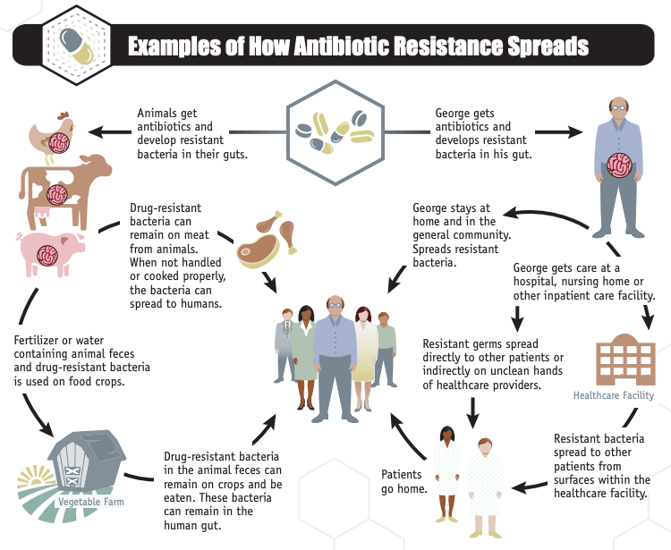

The on-going cycle of antibiotic resistance spread between humans, animals and the environment.
Source: Centers for Disease Control and Prevention (CDC). 2013. Antibiotic resistance threats in the United States, 2013. Atlanta, USA. Available at: www.cdc.gov/drugresistance/threat-report-2013/pdf/ar-threats-2013-508.pdf

The sheer magnitude and complexity of the AMR crisis and antimicrobial pollution results in the need for a coordinated and integrated One Health multi-sectoral approach inclusive of the public & animal health sectors, the agricultural production sectors (crops, forestry, fisheries, aquaculture & livestock), and the environment & ecosystem sectors.
At the African regional level, the Tripartite members (Food and Agriculture Organization of the United Nations - FAO, World Organisation for Animal Health - OIE, and World Health Organization - WHO), and the African Union (African Centre for Disease Control and Prevention – Africa CDC, African Union Inter-African Bureau for Animal Resources - AU-IBAR) and Regional Economic Communities (RECs) are working closely to combat AMR in a holistic continental One Health approach.

Communicating AMR in Africa
As Africa accelerates its AMR interventions, communication has been a key priority in the agenda. The first regional World Antibiotic Awareness Week 2019 was held in Kenya, bringing all the regional AMR stakeholders together in Nairobi creating dialogue from grass-root to policy levels.

In order to better communicate the risks of excessive or inappropriate use of antimicrobials and the importance of proactive participation from all levels of stakeholders, FAO Africa is pleased to welcome you to participate in this online forum to exchange ideas and discuss how to improve AMR communications in the region. Please find the following questions for your consideration and we look forward to receiving your inputs, suggestions and ideas.

- What is the biggest communication challenge related to AMR and inappropriate antimicrobial usage (AMU) in Africa?
- What is the best approach to communicate about other antimicrobials (antifungal, antiparasitic, antiviral, pesticides), and not only antibiotics? As viruses, fungi and parasites can also be resistant to medicines commonly used to treat them, and impacting health and food systems, how do we communicate about these issues in addition to antibiotic resistant bacteria?
- How can we get the topic of AMR included more often in the media? How do we ensure the visibility of AMR amongst other “hot topics”?
- What communication channels, methods or mechanisms are more suitable and will have the greatest impact at field level in African countries?
- Which group of stakeholders do you think should be considered as priority for targeted key messages aiming at raising awareness on excessive AMU and AMR?
- At national, regional and continental levels, who to do think should take leadership and responsibility for awareness and advocacy activities on AMU and AMR

Outcomes of this discussion will help provide insights to the Africa AMR Communications and Advocacy Strategy that is currently under development by the Regional Tripartite (FAO, OIE, WHO) and the African Union (Africa CDC and AU-IBAR).
We thank you for your valuable contributions and we look forward to incorporating your voices into the regional AMR communication strategy.

Scott Newman
Senior Animal Health and Production Officer and
FAO Secretariat to the Africa Tripartite One Health Regional Coordination Group
FAO Regional Office for Africa

