Call for best practices in transforming food systems for affordable healthy diets and addressing key drivers of food insecurity and malnutrition

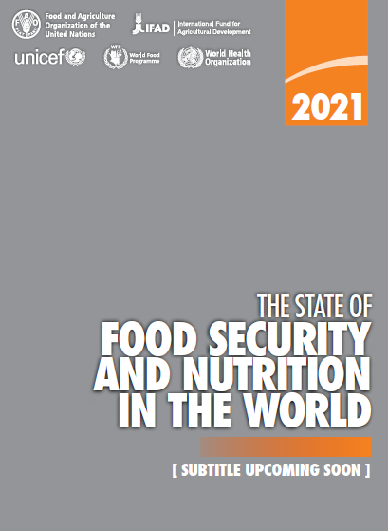
The inter-Agency writing team of the 2021 edition of The State of Food Security and Nutrition in the World (SOFI) invites you to share best practices and lessons learned in what it takes – in very practical and innovative ways – to transform food systems for better access to nutritious foods and affordable healthy diets.
Past editions of the SOFI Report have highlighted how key drivers, including conflict and civil strife, climate variability and extremes, economic slowdowns and downturns, persistent poverty and inequality, and now the COVID-19 pandemic, are worsening the state of food security and nutrition in the world and preventing hundreds of millions of people from accessing nutritious foods.
Latest trends speak for themselves: world hunger is increasing. Up by 10 million people in 2019, and nearly 60 million in five years. The COVID-19 pandemic is accelerating this rise – adding an additional 132 million more people in 2020 based on preliminary estimates. At the same time progress in reducing child stunting and wasting is slowing, and overweight and obesity is continuing to increase in rich and poor countries alike. More than 3 billion people in the world cannot afford a healthy diet.
In short, the world today is not on track towards ending hunger, food insecurity and malnutrition in all its forms by 2030 (Sustainable Development Goal/SDG-2). Getting on track towards achieving SDG-2 and other SDG’s will require a move away from silo solutions towards complementary food systems solutions and portfolios of policies and investments that address these global food security and nutrition challenges head on.
Food systems are failing to ensure nutritious and affordable foods for healthy diets, and this is made more difficult in the face of the key drivers we mention above. On the other hand, if food systems are transformed with strengthened resilience to the key drivers of food insecurity and malnutrition and are incentivized to provide affordable healthy diets sustainably and inclusively, they can put us on track towards achieving SDG-2.
With the above in mind, we invite you to share illustrative country examples of how food systems have been (or are being) transformed with strengthened resilience to the key drivers and ensure greater access and affordability of nutritious foods and healthy diets. The challenges in achieving such transformative changes are immense and require that we capitalize on win-win solutions, in which trade-offs and opportunities for efficiencies are effectively managed.
Should you have a compelling story to tell, or best practices or lessons learned to share on how best to address these challenges, we would like to invite you to focus on combined goals (food systems resilience to key drivers of food security and nutrition and affordability of healthy diets for all).
Please use the submission form to share your examples and experiences.
The co-facilitators of this Call will make a selection of the submitted best practices, which they will compile in a technical background paper, acknowledging the authors of the case studies. This will feed into the 2021 edition of The State of Food Security and Nutrition in the World (to be published in July 2021). In the selection process, we will consider:
- Applicability and relevance: initiatives representative of different country realities with regional and global perspectives.
- Policies, investments and other interventions across sectors that address two or more key drivers of food insecurity and malnutrition in all its forms, including conflict, climate variability and extremes, economic slow-downs and downturns, persistent poverty and inequality, and the economic and health implications of COVID-19.
- Engagement of public and private sector actors, including different government institutions, local communities, civil society, actors along the food supply chain, the food environment, consumers, others.
- Extent to which the innovation/transformative action helped increase access to nutritious foods and the affordability of healthy diets.
- Documented evidence: additional supportive information (electronic files, web links, etc.) of successful implementation of the best practice, impact of policies and initiatives on food security and nutrition, as well as additional opportunities, challenges and trade-offs linked to the intervention.
We look forward to receiving your valuable input and to learning from your experiences that would help make strengthen the SOFI 2021. To support you with questions on the content of the Call and of your submissions, you can contact the co-facilitators. Furthermore, an FSN Forum webinar will be organized during the first week of March (the date will be confirmed later) to further explore best practices in food systems transformation for affordable healthy diets.
Submissions are welcome in all six UN languages (English, French, Spanish, Russian, Arabic and Chinese).
The call is open until 31 March 2021.
You can upload the completed submission form on this webpage. To contact the SOFI team or for any technical support regarding downloading or uploading the submission form, please send an email to fsn-moderator@fao.org.
Your FSN Forum team and the co-facilitators:
Cindy Holleman, Senior Economist and Editor of The State of Food Security and Nutrition in the World, Agri-food Economics Division (ESA)
Mark Smulders, Special Advisor to the Report: The State of Food Security and Nutrition in the World 2021

The inter-Agency SOFI writing team consists of technical experts from FAO, IFAD, UNICEF, WHO and WFP.
SOFI 2017, SOFI 2018, SOFI 2019, SOFI 2020.
Please note that by “transformative change”, we refer to innovative, pro-active changes away from “business as usual”, and where the changes introduced lead to increased affordability of nutritious foods and healthy diets.

