Transforming food systems for affordable healthy diets and addressing key drivers of food insecurity and malnutrition

FSN Forum webinar in support of

“The State of Food Security and Nutrition in the World” (SOFI) 2021

List of panellists

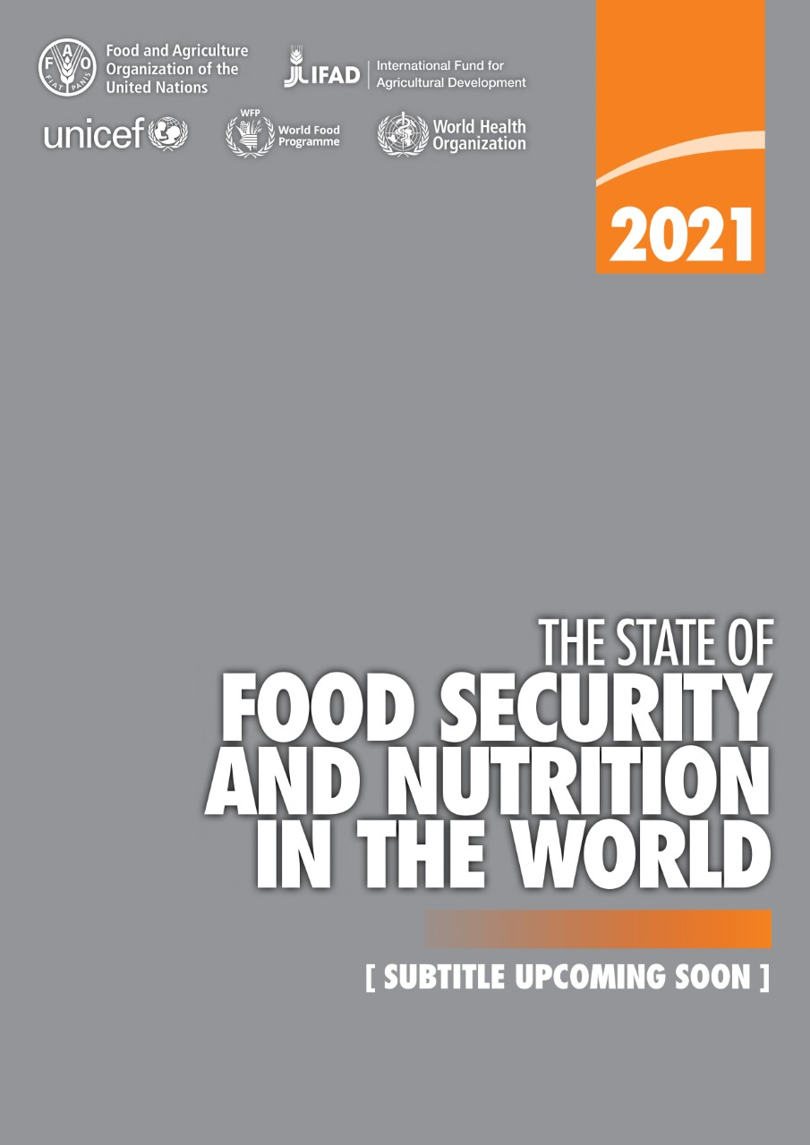
- Jessica Fanzo
Current position: Bloomberg Distinguished Professor of Global Food & Agricultural Policy and Ethics at Johns Hopkins University - Director of the Global Food Ethics and Policy Program, Johns Hopkins University, Washington DC, USA.
From 2017-19, Jessica Fanzo served as the Co-Chair of the Global Nutrition Report and the HLPE Report on Food Systems and Nutrition. She has also held positions at Columbia University, the Earth Institute and has consulted for FAO, WFP, Bioversity International and IFPRI.
Areas of expertise: PhD in Nutrition, University of Arizona. Researcher (agriculture, environment and climate, and health linkages to improve food systems and environments); diversity and quality of diets and nutrition outcomes; regaining food security and agriculture-based livelihoods in post-conflict regions through better governance and food policy; emerging area of equitable, ethical, and sustainable diets and food systems.
Recent relevant publication: Can Fixing Dinner Fix the Planet?
- Ndidi O. Nwuneli
Current position: Co-Founder and Managing Partner, Sahel Consulting Agriculture & Nutrition Ltd., Lagos, Nigeria.
Co-Founder, AACE Foods, which sources from over 10,000 farmers and produces packaged spices, seasonings and cereals for local and international markets. Founder, LEAP Africa. Chair, Nourishingafrica.com. TED Global speaker; work has been featured on CNN, BBC and international and local media outlets.
Former Senior Fellow, Mossavar-Rahmani Center for Business & Government, Harvard Kennedy School; Aspen Institute New Voices Fellow. Schwab Social Innovator and Young Global Leader, World Economic Forum. Member of UNFSS Action Track 1.
Started career as a Management Consultant with McKinsey & Company, Chicago, New York and Johannesburg offices. Recipient, National Honor, Nigerian Government. Member of the Board: Rockefeller Foundation, AGRA, Nigerian Breweries (Heineken), Godrej Consumer Products India, Fairfax Africa Holdings Canada, BusinessDay Newspapers, Royal DSM Sustainability Board, Netherlands, and the African Philanthropy Forum.
Areas of expertise: MBA, Harvard Business School; Wharton School, University of Pennsylvania. Expert on African agriculture and nutrition, philanthropy, and social innovation. Over 25 years of international development experience. Works across West Africa shaping agricultural policy, creating catalytic ventures, and implementing ecosystem solutions.
Recent relevant publications:

- Social Innovation in Africa: A Practical Guide for Scaling Impact
- Food Entrepreneurs in Africa: Scaling Resilient Agriculture Businesses
- Tim Benton
Current position: Research Director, Emerging Risks; Director, Energy, Environment and Resources Programme in the Chatham House, London, UK. He was also Dean of Strategic Research Initiatives at the University of Leeds.
Distinguished Visiting Fellow at Royal Institute of International Affairs, Chatham House; Global Agenda Steward for WEF; author for the IPCC's Special Report on Land, Food and Climate.
From 2011-2016 he was the “champion” of the UK’s Global Food Security programme which was a multi-agency partnership of the UK’s public bodies (government departments, devolved governments and research councils) with an interest in the challenges around food.
Areas of expertise: PhD Behaviour and Ecology, Cambridge University. Food systems; sustainability; climate change; ecology; evolution; agriculture; policy; biodiversity; population dynamics.
Recent relevant publications:
- Articulating the effect of food systems innovation on the Sustainable Development Goals. The Lancet Planetary Health. 5(1), pp. e50-e62
- Bundling innovations to transform agri-food systems. Nature Sustainability. 3(12), pp. 974-976
- Michael Carter
Current position: Professor of the Department of Agricultural & Resource Economics. University of California, Davis, USA.
Areas of expertise: His fields of interest are development economics, poverty dynamics, rural credit and insurance markets, agricultural development and income distribution, land tenure and land reform.
Recent relevant publications:
- Asset Insurance Markets and Chronic Poverty (forthcoming, in the link there’s a preliminary version)
- After the Drought: The Impact of Microinsurance on Consumption Smoothing and Asset Protection
- David Spielman
Current position: Senior research fellow at the International Food Policy Research Institute (IFPRI). He joined IFPRI in 2004 and is currently based in Kigali, Rwanda, where he leads the Rwanda Strategy Support Program.
Areas of expertise: David’s research agenda covers a range of topics including agriculture and rural development policy; agricultural science, technology, and innovation; plant genetic resources and seed systems; agricultural extension and advisory services; and community-driven rural development.
Recent relevant publications:
- Seed policies and regulatory reforms
- Demand for Complementary Financial and Technological Tools for Managing Drought Risk (co-author)
- Empowering women with digital extension in Uganda: Effects of information and role models (co-author)
- Robert F. Townsend
Current position: Robert Townsend is a Lead Economist in the Agriculture Global Practice at the World Bank, Washington DC, USA.
Areas of expertise: PhD in Agricultural Economics. He has worked on country operations in agriculture and food security in Africa, and Eastern Europe and Central Asia, and on related global programs including the Global Agriculture and Food Security Program and the Global Food Crisis Response Program. He was a core author of the World Development Report (WDR) 2008 on Agriculture for Development, and the lead author of a series of World Bank Group Agriculture Action Plans that took forward implementation of the WDR2008 within the World Bank Group. He has recently led preparation of a seven part series on the Future of Food, focusing on the agenda for the food system to end poverty and hunger by 2030, climate-smart agriculture, health and nutrition, jobs, financing, digital solutions, and fragile and conflict-affected situations.
Recent relevant publication: Responding to a stark rise in food insecurity across the poorest countries

