Policy outreach and communications - what works for improving food security and nutrition at the country level

Note:
- Submitted on September 11, 2014 to: Global Forum on Food Security and Nutrition (FSN Forum), Email: FSN-moderator@fao.org
- Contributor: Dr. Santosh Kumar Mishra (Ph. D.), Technical Assistant, Population Education Resource Centre (PERC), Department of Continuing and Adult Education and Extension Work, S. N. D. T. Women's University, Patkar Hall Building, First Floor, Room. No.: 03, 1, Nathibai Thackerey Road, Mumbai - 400020, Maharashtra, India. [Email: drskmishrain@yahoo.com Institutional Web Link: http://sndt.ac.in/ Tel.: +91-022-22066892 (O), +91–022–28090363 (R), +09224380445 (M)]

- What innovative strategies and channels have you used to reach policy makers and get feedback on their emerging needs?
I am researcher & demographer employed with the Population Education Resource Centre (PERC), S. N. D. T. Women’s University (SNDTWU, http://sndt.ac.in/), Mumbai, India. My academic activities at the PERC primarily include research and publication/material production. I resort to make direct contact with the policy makers through my research views and findings. I look at research not only as a tool for discovering innovative ideas, but also as medium for communication and dissemination of information and policy level strategies.
- Have you ever significantly changed your communication or policy outreach strategy? How did you change it? Did you get better results?
No, I have not significantly changed my communication or policy outreach strategy.
- What role do intermediaries (the media, “champions” in the government, etc.) play in helping you communicate your recommendations to policy makers?
Print media (including journals), in particular, influence policy makers to some extent. Of course, this strategy alone does not yield desired result. It also requires lobbying by influential social activists, researchers and other like-minded personnel. There has to be network of all these people in order to transport the recommendations to policy makers.
- If you are a policy maker or user of FSN information, how do you communicate your information needs to the information producers? What should information producers consider when trying to increase the use of their evidence by policy makers?
It is possible to communicate about the information need to the information producer ONLY IF both I and the information producer are PART OF THE SAME PROJECT/ORGANIZATION. The more people who enter this positive loop, the faster it spins. The more people who take part, the faster the human species learns.
- More than anything we would like to hear your success stories about what actually worked in terms of your information being used by policy makers!
In terms of what actually worked, it is an uphill ask to get insight into whether or not policy makers use the information provided. Information and input might have been institutionalized by the policy makers in one or several programs within the region of a country. But there is no mechanism to find out if this has actually happened.

Brief Resume of Contributor (Dr. Santosh Kumar Mishra)
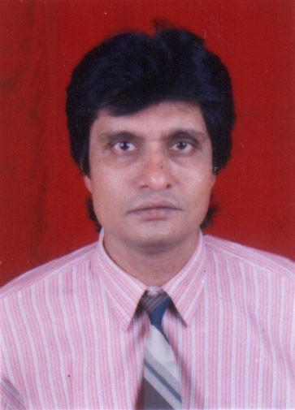
Dr Santosh Kumar Mishra is researcher & demographer employed with the S. N. D. T. Women’s University (SNDTWU, http://sndt.ac.in/) located at Mumbai in India. He underwent training in demography from the IIPS, Mumbai, India. (http://www.iipsindia.org/). He acquired Ph. D. in 1999. He is Reviewer/Editorial Board Member for 31 international journals. He has also reviewed papers for 5 international conference sessions, including EURAM 2014 Conference (4-7 June 2014, University of Valencia, Spain, http://site.aace.org). His subject areas of interest include: population & development education, issues pertaining to population-development linkages, education for sustainable development, adult & continuing education/non-formal/extension education, etc. Dr. Mishra has (a) co-authored 5 research studies (published by the SNDTWU); (b) presented 32 papers for national conferences & 11 papers for international conferences, & (c) authored/co-authored 5 handbooks/booklets (published by the SNDTWU, 5 books, & 11 book chapters. In addition, he has 30 articles published in national journals and 18 in international journals. Dr. was previously awarded Government of India fellowship at the IIPS (1986-1987) and travel scholarship for sharing his research views at international conferences and summits held at Karachi (Pakistan), Dare es Salaam (Tanzania), Stockholm (Sweden), Madison (USA), Dushanbe (Tajikistan), Canberra (Australia), and Manila (Philippines). He is Advisory Board Member of the American Academic & Scholarly Research Center (http://aasrc.org/?page_id=38) and Reviewer–cum–International Advisory Board Member for the AASRC 2013 International Conference – Beirut, Lebanon (http://aasrc.org/conference/? page_id=803).

