Global Renewable Fuels Alliance
2 St. Clair Avenue West, Suite 2100
Toronto, ON
M4V 1L5
Canada

May 20th, 2014

Luca Fratini
Chair of the Open-Ended Working Group on MYPoW
Global Forum on Food Security and Nutrition
Food and Agriculture Organization of the United Nations
Viale delle Terme di Caracalla
00153 Rome, Italy

Dear Minister Counsellor Fratini,

I am writing to you today in response to the Committee on World Food Security’s (CFS) call for topics to prioritize at the 2016-2017 biennium. The Global Renewable Fuels Alliance (GRFA) would like to begin by conveying its appreciation for maintaining a high level of stakeholder participation in consultations.

For the 2016-2017 biennium the Global Renewable Fuels Alliance would strongly suggest the topic of “Crude Oil and Food Security” to the CFS.

Crude oil and its price impact global food prices in many ways. The price of oil has a direct impact on the cost of fertilizer, the cost of packaging and the cost of transportation. The GRFA first highlighted the direct link between food and oil prices in March 2011 and has tracked it over subsequent years seeing a trend develop – the price of food follows the price of oil.

There is general consensus from international organizations on this topic. In 2011 David Hallam, the FAO’s Deputy Director confirmed this when he said;

“unexpected oil price spikes could further exacerbate an already precarious situation in food markets.”

Due to the severe impact crude oil prices have on food prices and therefore food security, GRFA members are of the opinion that the only way to address this important topic is by creating its own “Crude Oil and Food Security” work stream. Like other topics of similar importance the work stream would conclude with an HLPE report with suggestions on how to lessen crude oil’s impact on food prices and food security.

The GRFA would welcome the opportunity to assist the Chair of the Open-Ended Working Group to develop the scope of the working group if the topic were chosen in the future.

Please feel free to contact me at info@globalrfa.org or visit www.globalrfa.org.

Sincerely,

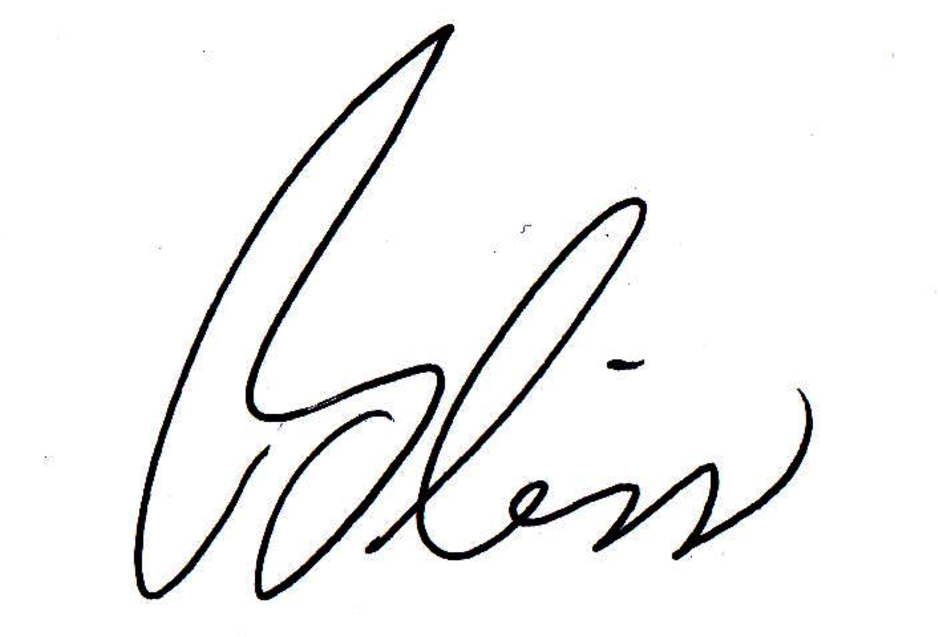

Bliss Baker
President
Global Renewable Fuels Alliance

