“Living Farms Green College” Celebrated “International Indigenous People’s Day”and “Green Day” Jointly in Kachapaju a Remote Tribal Village of Bissamcuttack Block in Rayagada Dist.of Odisha

On dated 12th August 2016 Livingfarms Green College,Muniguda,Rayagada[ a Non Profit organization and an adult learning Innovative College in Tribal pockets of Odisha, which is affiliated to Agriculture Skill Council(ASCI),India and funded by GIZ-WHL-SDTT for Executing Adult and Extension Education based on Green Vocation like Agriculture, Natural Resources and Other allied activities based on Livelihood.] Celebrated the International Indigenous Peoples Day and Green day jointly with the tribal rural college students and staffs with enthusiasm. In this occasion a general meeting was conducted and discussion was made on Tribal’s Importance for setting up a human civilization by Tribal culture and traditional wisdom.For Protection of Tribals in Schedule areas PESA act should be implemented as Rayagada Dist. Is under schedule area to make the slogan”Our Rules,Our Country”(Hamara Raj….Hamara Desh).Apart from these for Green Day purpose ,How the Biodiversity, and Our Mother Earth become Green and Beautiful forever by saving our forest,nature and climate was discussed vividly.We should practice “Good Agriculture Practice” and “Good Climatic Pracice” to check the environmental pollution and hazards related to our Climate,Environment and Whole globe.A good sign was marked in this meeting that all the Student participants were Rural Youth Tribals and this was prompted for “Attracting and Retaining Rural Tribal Youths in Agriculture and Climate”.(ARTYAC) for saving our culture, society and Climate with a Sustainable way as Tribal’s were Innocent and Lover of Nature.This is a good and great beginning.
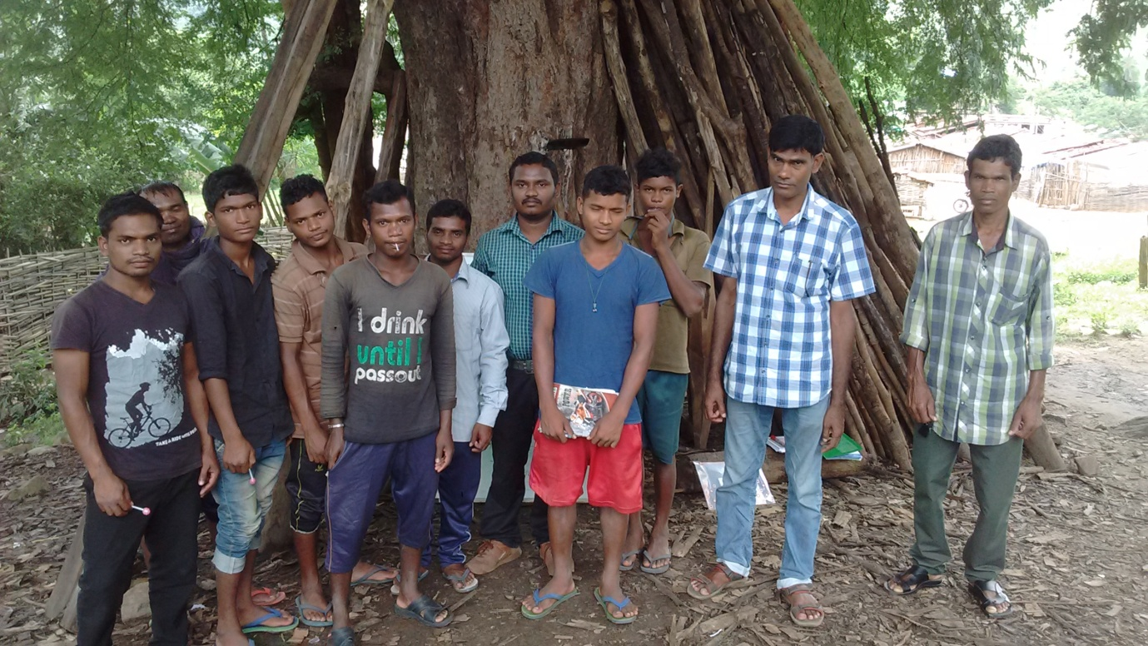
The meeting and discussion was presided by Bibhu Santosh Behera, Independent Scientist (Climate Smart Extension Education) and Principal ,Living Farms Green College,Muniguda,Rayagada.Finally after meeting thank you note was given by Kamalakanta Barik, a Social Resaercher and Lecturer of this College.Apart from these for this meeting Debjit Sarangi,Managing Trustee and Social Activist of Living Farms was conveyed his greetings and message on behalf of this auspicious day along with Dr.Debal Deb,International Rice Scientist.Finally Principal of Green College acknowledged and conveyed his thankful greetings to all Green College Staffs,Students,Media and Family members of Living Farm for their direct and indirect help to make this occasion a grand success.

